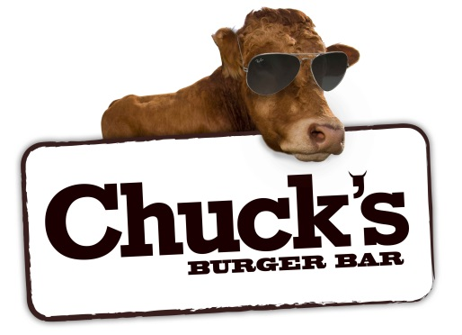
To whom it may concern,

Chucks Burger Bar in Sidney is looking for a new addition to our team! We are seeking someone interested in a dishwasher position Thursday through to Saturday evenings making wage plus tips. We are looking for someone wanting to gain work experience or to help save their way to Post Secondary school. Experience is not necessary, just a positive attitude, a way to get to work and be reliable. Days off are almost always granted with a heads up, our staff are all friendly and easy to get along with! We are also willing to train someone for prep work and cooking on line through the summer months if they are wanting more hours. We are very flexible around sports, school work and other obligations. If you have anyone interested in this position or wanting more details, Please have them drop a resume off to the Chucks Burger Bar located on 2031 Malaview Ave, West Sidney and ask for Meaghan or give Meaghan a call at 778-678-6324.

Thank you for your time,
Meaghan Philip
Manager

