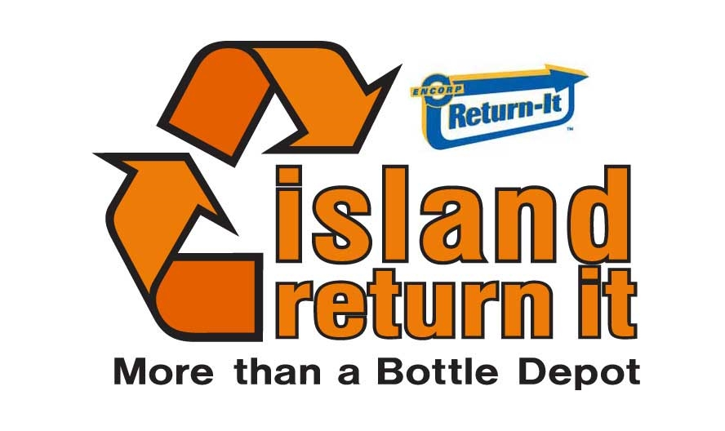

Looking for a high-energy, positive work environment with great coworkers and great perks? Island Return It is looking for Customer Service/Recycling Representatives to join our team at our Sidney location *#5-10025 Galaran, Sidney,BC*

THE JOB
Our Customer Service/Recycling representative are the backbone of our operation. They’re the go-to folks to get ‘er done! In this fast-paced role, there’s lots of variety – you’ll be helping customers, counting, sorting, working the return till and keeping our facilities tidy.

YOU’LL FIT IN AT ISLAND RETURN IT IF:
- You have solid basic math skills (yep, there are some numbers involved).
- You can lift up to 30 lbs safely and like to be physically active at work.
- You’re a multi-tasker and team player who’s organized, reliable, keen, and works hard!

If you’re interested in being part of our mission to make communities (and the planet) greener, send us your resume or drop by in-person – we’d love to meet you!
sophy@islandreturnit.com - #5-10025 Galaran Rd.

