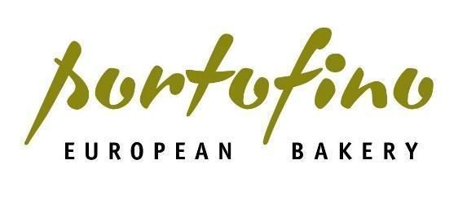
Who We Are:
We believe people should never settle for boring baked goods, ever.
We are Portofino Bakery, one of British Columbia’s fastest-growing bakeries, serving an increasing network of local grocery and foodservice customers across Western Canada.
Portofino Bakery was founded over 15 years ago in Victoria, BC with the mission to provide better artisan bread to the local community in Victoria. Today, we have over 175 team members, 3 facilities and are continuing our mission to enrich the lives of our customers with every baked good.
Portofino Bakery is part of Bond Bakery Brands, a stakeholder-focused investment platform started by three friends, and includes Pace Processing & Product Development, Holy Napoli and Coco Bakery. Together, we are building better bakeries.
The Bread and Butter of the Position:
If you take pride in making things squeaky clean and aren’t afraid to use a little elbow grease, our Custodian Team Member position may be right for you. As an important part of our day-to-day operations, our Custodian Team Members work behind the scenes to ensure our commercial bakery maintains the highest levels of cleanliness and sanitation.
Reporting to our Quality Assurance Manager, our Custodian Team Members are responsible for:
- Completing the sanitation shift duties as assigned by the Sanitation Supervisor
- Disassembling, sanitizing, and reassembling food processing equipment as per Sanitation Standard Operating Procedures (SSOPs)
- Assisting in premise cleaning to ensure compliance to General Manufacturing Practices (GMP)
- Locking-out, dismantling, cleaning and sanitizing production equipment in accordance with the master sanitation schedule and sanitation standard operating procedures
- Using approved cleaning chemicals, cleaning methods, personal protective equipment and cleaning equipment, as per GMP standards, training and safety requirements, at all times
- Assisting in ensuring all janitorial and sanitation tasks are completed as per the company schedule
- Documenting all cleaning and sanitation activities when completed and reporting deficiencies to the Sanitation Supervisor/QA Manager.
- Working in a safe and conscientious manner, as well as independently with minimal supervision
- Adhering to all safety standards, Workplace Hazardous Materials Information Systems (WHMIS) and GMPs
- Working with the Maintenance team members to ensure the production facility and production equipment is properly maintained.
- Other duties as assigned
Shifts and availability:
- 8 hour shifts.
- Must be available to start work at 7:00am.
- This is a full-time seasonal position with the flexibility to extend in the Fall.
The Ingredients You Bring to the Table:
- Previous experience in a sanitation, custodian or janitorial role, preferably in a highly regulated environment
- Knowledge and experience with sanitation programs, including the 7 steps of cleaning
- Knowledge and experience with GMP standards and procedures
- Comfortable with WHMIS, First Aid, Health and Safety legislation
- Comfortable with Health Canada regulated environments and protocols
- Comfortable working at heights, fall arrest is considered an asset
- HACCP knowledge is considered an asset
- Strong verbal communication skills
- The ability to work independently, as well as in a group
- The ability to work on your feet for extended periods
- The ability to work in a clean, organized manner
- The ability to lift up to 50lbs
- A commitment to upholding company policies, compliance and quality standards
- A willingness to learn and grow
The Details You’ll Loave:
- $18.50 starting wage
- Healthy and frequent raises
- Medical & Dental benefits including Life Insurance after 3 months, if you work at least 30 hours per week
- Access to complimentary "staff bread" to take home
- Opportunity for advancement
- Paid Training
- Uniforms Provided
Our Values and What We Expect From Our Bread head Team Members:
Commitment
- We are committed to operating in a safety-first environment.
- We are committed to providing a positive work environment.
- We are committed to being a part of Portofino’s future growth and company goals.
- We are committed every day to making and delivering products we can be proud of.
People
- We listen and value input from everybody– we have open doors at Portofino Bakery.
- We use the golden rule and treat each other with respect, even when our opinions differ.
Performance
- We overcome challenges together as a team, we are stronger together.
- We do not take shortcuts; we do things right.
- We believe making the best products with better ingredients matters a lot.
- We believe in continuous product innovation and getting people excited about baked goods.
Inclusivity Statement:
At Portofino Bakery, we believe that diversity of experience, opinion and background is fundamental to our future growth. We believe success happens where new ideas can flourish – in an environment where people from various backgrounds can work productively together. Portofino Bakery is committed to creating a diverse environment. All qualified applicants will receive consideration for employment without regard to race, color, religion, gender, gender identity or expression, sexual orientation, national origin, genetics, disability or age.
A Division of:

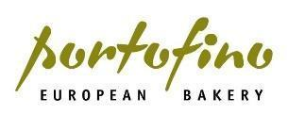
Members of the Bond Bakery Brands family include:

