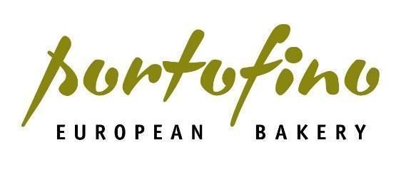
Who We Are:
We believe people should never settle for boring baked goods, ever.
We are Portofino Bakery, one of British Columbia’s fastest-growing bakeries, serving an increasing network of local grocery and foodservice customers across Western Canada.
Portofino Bakery was founded over 15 years ago in Victoria, BC with the mission to provide better artisan bread to the local community in Victoria. Today, we have over 175 team members, 3 facilities and are continuing our mission to enrich the lives of our customers with every baked good.
Portofino Bakery is part of Bond Bakery Brands, a stakeholder-focused investment platform started by three friends, and includes Pace Processing & Product Development, Holy Napoli and Coco Bakery. Together, we are building better bakeries.
The Bread and Butter of the Position:
If you are organized, detail oriented and love bread, our Packaging Team Member position could be just what you are looking for in your next job. Our Packaging Team Members perform a wide range of duties that involve the packaging of Portofino Bakery products - our bread would not get to customer shelves without packaging!
Reporting to the Plant Manager, our Packaging Team Members are responsible for:
- Performing a wide range of duties to ensure the packaging of all Portofino products
- Following specified production lists
- Assessing product and using thermometers to determine whether it is ready to be sliced and packaged
- Once the product has cooled, organizing it as per company protocol
- Ensuring all products are sliced, packaged, labelled and dated accurately in accordance with company policies and compliance requirements
- Operating the slicers and ensuring required product is sliced to appropriate thickness
- Reporting any errors or damages
- Ensuring the work area is properly stocked with the correct packaging materials and that management is aware of any low or out of stock products
- Putting away all loose packaging supplies and tools
- Washing and sanitizing all equipment, tools and, workspaces
- Ensuring all equipment is turned off and stored for the next day
- Ensuring to follow and record on cleaning and sanitation checklists
- Keeping product rotated and following FIFO standards (First in First out)
- Other duties as assigned
Shifts and availability:
- 8 hour shifts.
- Must be available to work 3:30pm-midnight.
- This is a full-time seasonal position with the flexibility to extend into the Fall.
The Ingredients You Bring to the Table:
- Strong verbal communication skills
- The ability to work independently, as well as in a group
- The ability to work on your feet for extended periods
- The ability to work in a clean, organized manner
- The ability to lift up to 50lbs
- A commitment to upholding company policies, compliance and quality standards
- A commitment to punctuality and reliability, reporting to work on time as scheduled
- A willingness to learn and grow
- Previous experience in a warehouse environment is considered an asset
- Previous experience with HACCP is considered an asset
- Food Safe Level 1 is required
The Details You'll Loave:
- Starting wage is $20.00 per hour
- Healthy and frequent raises
- Medical & Dental benefits including Life Insurance after 3 months, if you work at least 30 hours per week
- Access to complimentary "staff bread" to take home
- Bi-annual Footwear Allowance
- Opportunity for advancement
- Paid Training
- Uniforms Provided
Our Values and What We Expect From Our Breadhead Team Members:
Commitment
- We are committed to operating in a safety-first environment.
- We are committed to providing a positive work environment.
- We are committed to being a part of Portofino’s future growth and company goals.
- We are committed every day to making and delivering products we can be proud of.
People
- We listen and value input from everybody– we have open doors at Portofino Bakery.
- We use the golden rule and treat each other with respect, even when our opinions differ.
Performance
- We overcome challenges together as a team, we are stronger together.
- We do not take shortcuts; we do things right.
- We believe making the best products with better ingredients matters a lot.
- We believe in continuous product innovation and getting people excited about baked goods.
Inclusivity Statement:
At Portofino Bakery, we believe that diversity of experience, opinion and background is fundamental to our future growth. We believe success happens where new ideas can flourish – in an environment where people from various backgrounds can work productively together. Portofino Bakery is committed to creating a diverse environment. All qualified applicants will receive consideration for employment without regard to race, color, religion, gender, gender identity or expression, sexual orientation, national origin, genetics, disability or age.
A Division of:

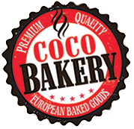
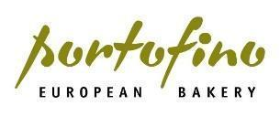
Members of the Bond Bakery Brands family include:

